**Special instructions:** You may work with two other student for a maximum three person team. You must create a repository for your work on github and invite profSmay to be a collaborator.

**Problem 1**

Build a graphical user interface for calculating the properties of steam by specifying any two properties. A .ui file has already been converted to a .py file for you and the only code you need to fix is in Calc_state_app_stem.py. The successful program should look like below after selecting two properties and clicking the Calculate buton

**Problem 2**

Build a graphical user interface for the Rankine problem on exam 2. The GUI should:

1. accept low and high isobar values and inform the user of saturated properties for these pressures
2. allow the user to decide if the turbine inlet state should be saturated or superheated steam
3. allow the user to specify the turbine isentropic efficiency
4. calculate the rankine cycle performance upon a button click

The GUI should look similar to:

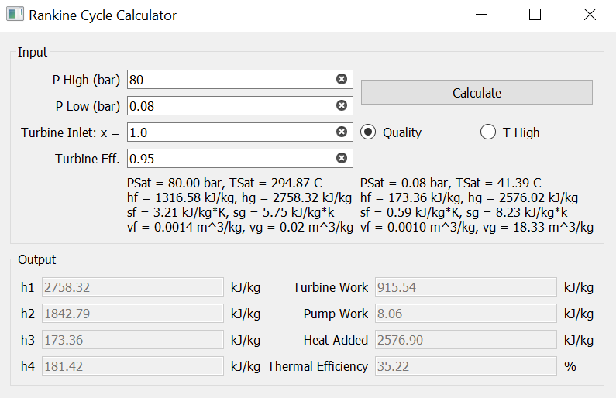

The ui file I created is available for you to use as a starting point.